Lab Assignment #5
Stress on a Joint

EAE 133 - Finite Element Methods in Structures
Professor N. Sarigul-Klijn
TA: Noah Derita

Aurian Malhotra
920005606
Section A04, 10/30/2025

Introduction
The purpose of this lab is to analyze the stress distribution and deformation of a thin steel plate with an eyelet subjected to a tensile load. The plate is modeled as a 2D finite element mesh with thickness t = ⅛ in, Young’s modulus E = 2.95 x 10⁷ psi, Poisson’s ratio v = 0.3, and yield strength SY = 3.4 x 10⁴ psi. The eyelet is subjected to a 1000 lb load distributed along the bottom half of the eyelet opening. The goal of the analysis is to perform a mesh convergence study and determine the nodal displacements and stresses in the plate.

A sequence of five meshes with increasing refinement is used to evaluate convergence of the maximum displacement as a function of element count. The final, most refined mesh is then used to examine the deformed shape and stress contours in detail.

Figure 1: Joint Subject to Stress
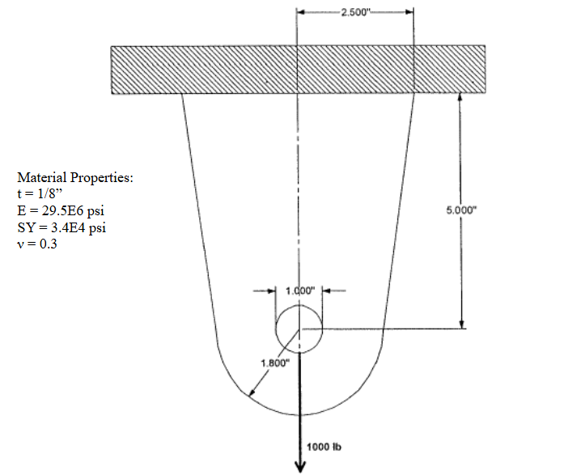

Procedure:
The 2D plate geometry with an eyelet (Figure 1) was modeled in Patran, representing a thin steel plate constrained along the top edge. The origin was placed at the center of the circular hole, and ten key points were created to define the plate’s boundaries. Curves were then generated to form the outer plate edges and the circular hole. These curves were broken and trimmed to produce ten uniform subdomains for meshing

Ten surfaces were created from the defined curves. A 2D membrane property was assigned with a thickness of ⅛ in, and isotropic steel material properties of E = 2.95 x 10⁷ psi, v = 0.3, SY = 3.4 x 10⁴ psi. The upper boundary was fully constrained, and a total load of 1000 lbs was applied along the bottom half of the hole using an edge load definition.

Five mesh densities were analyzed using global mesh seeds of 2, 5, 10, 20, and 40. Each model was meshed with Quad4 elements using the IsoMesh method (Figure 2) and analyzed with MSC NASTRAN. Minimum and maximum stress and displacement values were extracted from the .f06 file, and stress fringe plots were generated in Patran.

Figure 2: Mesh Structures with Relevant Mesh Size
Mesh Element Size | Mesh Structure
2 | 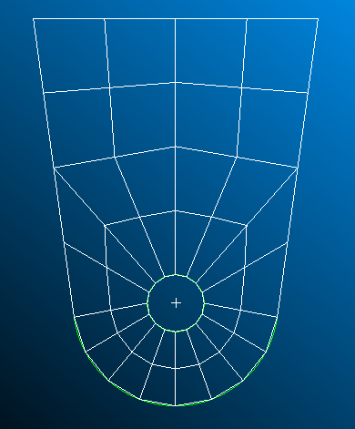
5 | 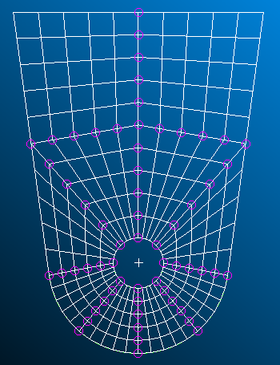
10 | 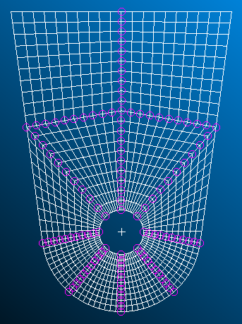
20 | 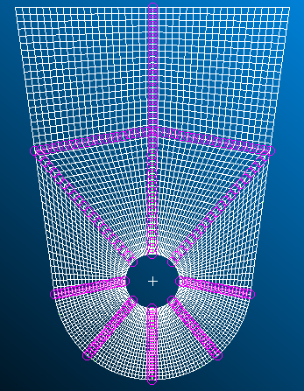
40 | 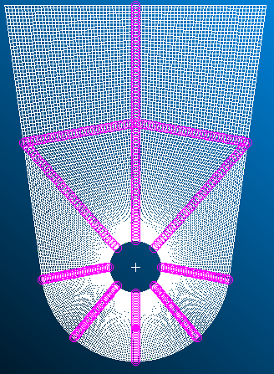

Result
The sequence of meshes in Figure 2 shows how the joint geometry is increasingly resolved as the element size decreases. The coarsest mesh with a seed of 2 produces only a crude approximation of the plate and eyelet, while the finest mesh with a seed of 40 captures the circular hole and surrounding fillet much more smoothly. As the mesh is refined, the element density becomes highest around the hole, where large stress gradients are expected, and the boundaries of the subdomains appear more uniform and structured, consistent with the deliberate subdivision defined in the guide.

Figure 3: Stress/Deformation Plot of 40-Element Mesh
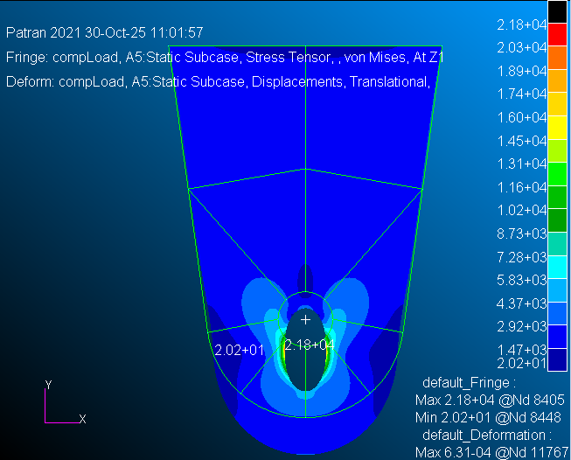

Figure 3 presents the deformed shape and stress contour for the final, most refined mesh (mesh seed = 40). The deformation is scaled for visualization, but the qualitative behavior is physically reasonable: the plate deforms downward from the fixed top edge, and the eyelet translates downward in the direction of the applied 1000 lb edge load along the bottom half of the hole. The upper boundary remains essentially rigid due to the applied displacement constraints, while the central and lower regions of the plate experience the largest deflections. The stress contour shows peak stresses forming around the inner edge of the eyelet, particularly along the loaded lower half and the transition between the circular hole and the surrounding plate. This is characteristic of a plate with a loaded hole, where local stress concentrations occur adjacent to the opening.
Table 1: Minimum/Maximum Stress and Displacements for 40-Element Mesh
 | Displacement (in) |  | Stress (psi)
 | X | Y | X | Y
Min | 0.0 | 0.0 | 2.216914E+04 | 9.116036E+02
Max | 1.0261827E-04 | -6.313955E-04 | 2.016911E+01 | 2.330155E+00

Table 1 summarizes the minimum and maximum displacements and stresses for the final mesh. The minimum displacement occurs at the constrained top boundary where both x- and y-translations are zero. The maximum horizontal displacement is on the order of 1.026E-04 in, and the maximum vertical displacement magnitude is approximately 6.314E-04 in. The stress data indicate peak stresses of about 2.22E+04 psi, which remain below the specified yield strength of 3.4E+04 psi. This corresponds to a factor of safety of roughly 1.5 with respect to yielding at the most critical locations.

The convergence study results are plotted in Figure 4 as maximum displacement vs mesh seed. As the mesh is refined, the maximum displacement values approach a stable limit, with the largest changes occurring between the coarsest meshes and only small differences between the 20 and 40 element cases. The convergence curve flattens for the two finest meshes, indicating that the solution is effectively mesh-independent at higher mesh densities and that the 40 seed mesh is sufficiently refined for accurate prediction of global deformation and peak stresses.

Figure 4: Convergence Plot
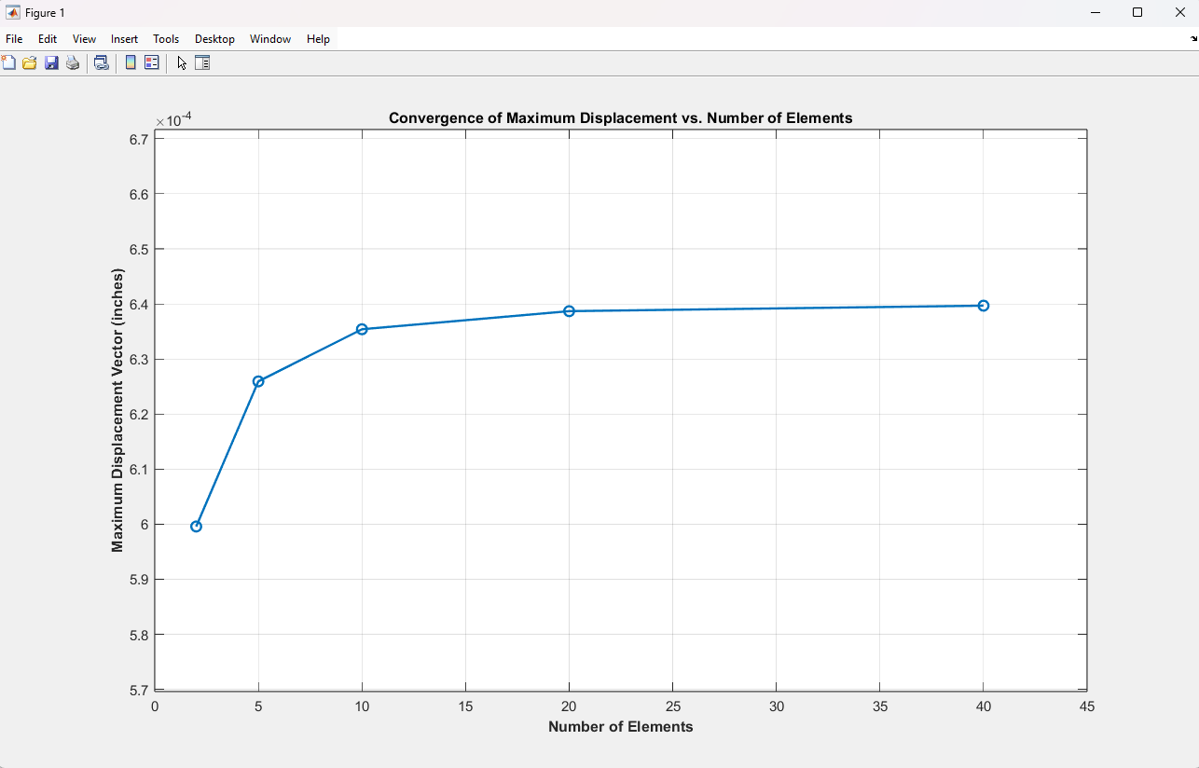
Discussion/Conclusions
The finite element results for the joint under a 1000 lb load demonstrate behavior that is consistent with both the boundary conditions and the expected mechanics of a plate with a loaded hole. With the top edge fixed, the plate hangs from the constrained boundary while the eyelet and surrounding material deform downward under tension. The largest displacements occur near the loaded lower portion of the hole, and the deformation field decays toward the fixed top edge, which remains essentially stationary. This pattern confirms that the constraints and applied edge load were implemented correctly.

The stress contours from the final refined mesh clearly show a strong concentration of stress along the inner edge of the eyelet, particularly along the lower semicircle where the load is applied and in the fillet region where the hole blends into the main plate. These high-stress zones represent the critical locations where damage or yielding would first occur if the load were increased or subjected to repeated cycles. However, the computed maximum stress remains below the material yield strength, indicating that, for the applied 1000 lb load, the joint is operating within the linear-elastic range with a reasonable factor of safety.

The convergence study confirms that the structured mesh and deliberate subdivision of the domain lead to a stable and reliable solution. As the mesh seed increases from 2 to 40, the maximum displacement quickly approaches a limiting value, and the difference between the 20- and 40-seed cases is small, showing that further refinement would not significantly change the global response. From an engineering perspective, this means that the 40-seed mesh provides an efficient balance between computational cost and accuracy.

